**COAL LAB 9**

Name = Ayesha tayyaba

Sap id = 56546

Instructor = Ayesha Ikram

HOME

**TASK 1:**

.model small

.stack 100h

.data

msg1 DB 10,13, "Enter First Number (A): $"

msg2 DB 10,13, "Enter Second Number (B): $"

msg_gt DB 10,13, "A is greater than B$"

msg_lt DB 10,13, "A is less than B$"

msg_eq DB 10,13, "A is equal to B$"

.code

main proc

mov ax, @data

mov ds, ax

mov dx, offset msg1

mov ah, 9

int 21h

mov ah, 1

int 21h

mov bl, al

mov dx, offset msg2

mov ah, 9

int 21h

mov ah, 1

int 21h

mov bh, al

mov al, bl

cmp al, bh

je label_equal

ja label_greater

jb label_less

label_equal:

mov dx, offset msg_eq

mov ah, 9

int 21h

jmp exit_prog

label_greater:

mov dx, offset msg_gt

mov ah, 9

int 21h

jmp exit_prog

label_less:

mov dx, offset msg_lt

mov ah, 9

int 21h

exit_prog:

mov ah, 4ch

int 21h

main endp

end main

**Output:**

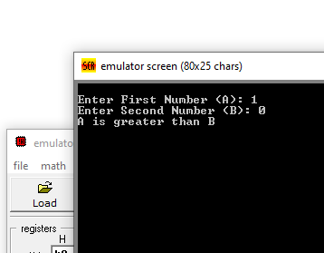

**TASK = 2:**

.model small

.stack 100h

.data

msg1 db 10,13, "Enter a one-digit number (0-9): $"

msg_zero db 10,13, "The number is Zero.$"

msg_pos db 10,13, "The number is Positive.$"

.code

main proc

mov ax, @data

mov ds, ax

mov dx, offset msg1

mov ah, 9

int 21h

mov ah, 1

int 21h

mov bl, al

cmp bl, '0'

je is_zero

mov dx, offset msg_pos

mov ah, 9

int 21h

jmp exit_prog

is_zero:

mov dx, offset msg_zero

mov ah, 9

int 21h

exit_prog:

mov ah, 4Ch

int 21h

main endp

end main

**Output:**

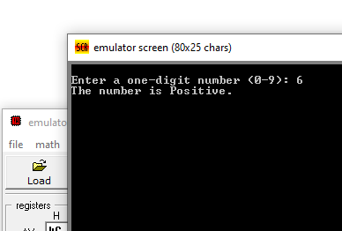

**TASK 3:**

.model small

.stack 100h

.data

msg1 db 10,13, "Enter a one-digit number (0-9): $"

msg_even db 10,13, "The number is Even.$"

msg_odd db 10,13, "The number is Odd.$"

.code

main proc

mov ax, @data

mov ds, ax

mov dx, offset msg1

mov ah, 9

int 21h

mov ah, 1

int 21h

sub al, '0'

mov bl, al

mov ah, 0

mov al, bl

and al, 1

cmp al, 0

je print_even

print_odd:

mov dx, offset msg_odd

mov ah, 9

int 21h

jmp exit_prog

print_even:

mov dx, offset msg_even

mov ah, 9

int 21h

exit_prog:

mov ah, 4Ch

int 21h

main endp

end main

**Output:**

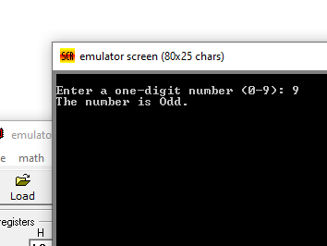

**TASK 4:**

.model small

.stack 100h

.data

msg1 db 10,13, "Enter your marks (0-9): $"

msg_less db 10,13, "Need hard work.$"

msg_more db 10,13, "Satisfactory.$"

.code

main proc

mov ax, @data

mov ds, ax

mov dx, offset msg1

mov ah, 9

int 21h

mov ah, 1

int 21h

sub al, '0'

cmp al, 5

jl label_less

mov dx, offset msg_more

mov ah, 9

int 21h

jmp exit_prog

label_less:

mov dx, offset msg_less

mov ah, 9

int 21h

exit_prog:

mov ah, 4Ch

int 21h

main endp

end main

**Output:**

